# Ignition Coil

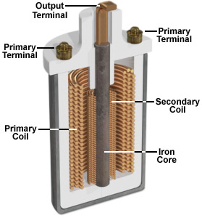Now most automobiles run on gasoline, which they burn in an internal combustion engine to convert into motion. For combustion to take place, a spark is needed to ignite the fuel mixture in the engine. The vehicle’s ignition system is designed so that a 12-volt battery can generate the very high voltage required to create such a discharge. The heart of this system is a device called an ignition coil.

Figure 1: Internal of ignition coil

This coil is a kind of transformer. Transformers transfer voltage from one circuit to another, either as a higher voltage (as in a step-up transformer, of which the ignition coil is an example), or a lower voltage (a step-down transformer). The key principle that makes transformers work is electromagnetic induction: a moving magnetic field, or a change in a stationary magnetic field (the case in our ignition coil), can induce a current in a wire exposed to that field.

This ignition coil is a pulse-type transformer. Like other transformers, it consists, in part, of two coils of wire. These are both wrapped around the same iron core. Because this is a step-up transformer, the secondary coil has far more turns of wire than the primary coil, which is wrapped around the secondary. In fact, the secondary coil has several thousand turns of thin wire, whereas the primary coil has just a few hundred. In your car, this allows some 40,000 volts of electricity to be generated by a modest battery.

**The basic principle of an ignition coil**

To produce the required high voltages, ignition coils make use of the relationships that exist between electricity and magnetism.

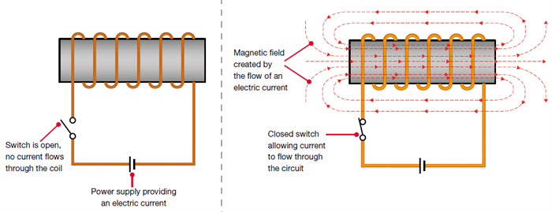When an electric current flow through an electrical conductor such as a coil of wire, it creates a magnetic field around the coil. The magnetic field (or, more precisely, magnetic flux) is effectively a store of energy, which can then be converted back into electricity.

Figure 2: Creating a magnetic field by flowing electric current through a coil

When the electric current is initially switched on, the current flow rapidly increases to its maximum value. Simultaneously, the magnetic field or flux will progressively grow to its maximum strength, and will become stable when the electric current is stable. When the electric current is then switched off, the magnetic field will collapse back in towards the coil of wire.

**There are two main factors that affect the strength of the magnetic field:**

1. Increasing the current being applied to the coil of wire strengthens the magnetic field
2. The higher number of windings in the coil, the stronger the magnetic field.

**Operation of Ignition coil**

For ignition coils (and many types of electrical transformer), the secondary winding is made with more windings than the primary winding. When the magnetic field collapses, it will therefore induce a higher voltage into the secondary winding than into the primary winding.

The secondary winding has more coils than the primary winding. When the magnetic field collapses, the voltage in the secondary coil will be greater than the voltage induced in the primary winding.

The primary winding of an ignition coil will typically contain 150 to 300 turns of wire; the secondary winding will typically contain 15,000 to 30,000 turns of wire, or around 100 times more than the primary winding.

The magnetic field is initially created when the vehicle’s electrical system applies approximately 12 volts to the ignition coil’s primary winding. When a spark is required at a spark plug, the ignition system will switch off the current flow to the primary winding, which will cause the magnetic field to collapse. The collapsing magnetic field will induce a voltage into the primary winding in the region of 200 volts, but the voltage induced into the secondary winding will be approximately 100 times greater, around 20,000 volts.

By using the effects of mutual inductance and by using a secondary winding that has 100 times more windings than the primary winding, it is therefore possible to transform the original 12-volt supply into a very high voltage. This process of changing a low voltage into a high voltage is referred to as the ‘transformer action’.

In an ignition coil, the primary and secondary windings are wrapped around an iron core, which helps concentrate and enhance the strength of the magnetic field and flux, thus making the ignition coil more efficient.

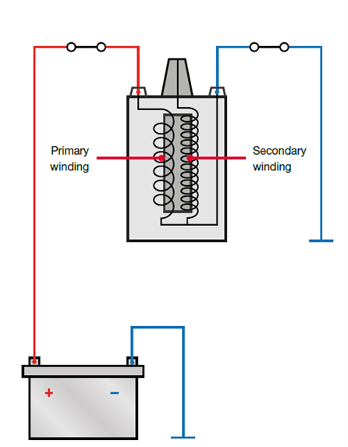.

Figure 3: Operation of Ignition coil

**WASTED SPARK IGNITION SYSTEMS**

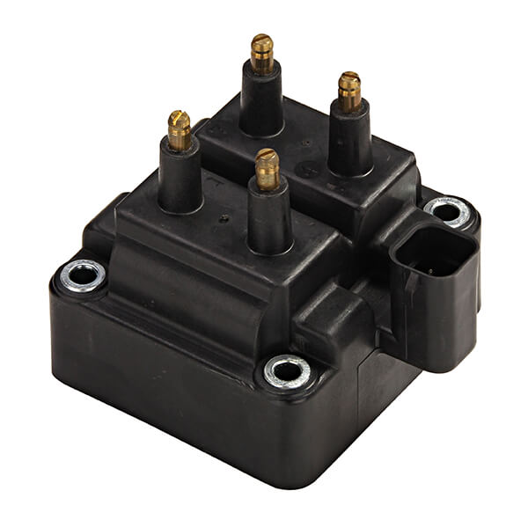Wasted spark ignition systems are a type of DIS, which uses one coil for every two cylinders. The coil provides the spark for one of the paired cylinders on the compression stroke and to the other on the exhaust stroke. Because the coil fires the spark plug on the exhaust stroke as well, it is appropriately named 'wasted spark ignition'. In effect, the spark plugs fire simultaneously and twice as often.

Figure 4: WASTED SPARK IGNITION COIL

Ignition Coil One of the two paired spark plugs is always negative polarity while the other spark plug is always positive polarity. Negative polarity means the spark plug's center electrode is negatively charged and its ground electrode is positively charged. Positive polarity is the opposite. Each time the plug fires, a rapid exchange of the protons and electrons occurs, called ionization.

The negatively charged electrons will be attracted to whichever side of the spark plug that is positively charged. The positively charged protons have much more mass than electrons, and thus cause more wear on the electrode they collide with. Hence, one plug will exhibit more wear on its ground electrode, while the other plug will experience more wear on its center electrode. If a spark plug with a precious metal on only the center electrode were to be used with this type of ignition system, there would be uneven wear on half the plugs. Although single precious metal or standard nickel plugs will still allow the engine to run, plug life will be greatly reduced.

Therefore, if a vehicle was originally equipped with dual precious metal spark plugs, replacement with a single precious metal or standard nickel plug may reduce plug life and engine performance.

In a four-cylinder engine, for example, cylinders 1 and 4 are connected to one ignition coil, and cylinders 2 and 3 to another. The ignition coils are triggered by the ignition output stages in the electronic control unit. This receives the TDC signal from the [crankshaft sensor](https://www.hella.com/techworld/uk/Crankshaft-sensor-4506/) in order to begin triggering the correct ignition coil.

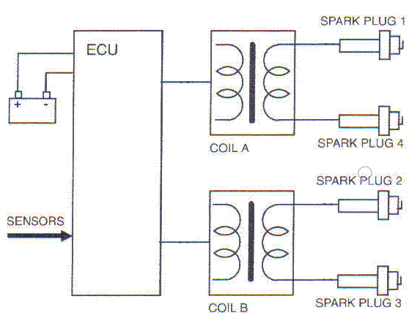

Figure 5: WASTED SPARK IGNITION SYSTEMS

**The advantage of Wasted spark ignition systems**

That no distributor is needed, so there is no mechanical parts, wear or voltage drops. As a result, the coil needs less energy so can be made smaller. Usually in a 4-cylinder engine we’ll have two coils in one body – coil pack.

**The disadvantage of Wasted spark ignition systems**

Is that there is firing in the exhaust strokes which implies that no fuel mixture may enter at that time because of valve overlap or any other reason. Otherwise, the fuel mixture will explode in the cylinder when is it at exhaust stroke and coarse damage to the engine. As result it is not always possible to get an optimum ignition timing. The other disadvantage is that those systems are more difficult to diagnose than the other ignition systems.

**Spark Plug**

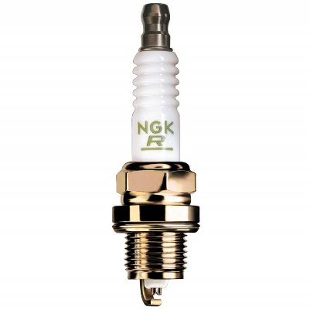A spark plug is an electrical device that fits into the cylinder head of some internal combustion engines and ignites compressed aerosol gasoline by means of an electric spark. Spark plugs have an insulated center electrode which is connected by a heavily insulated wire to an ignition coil or magneto circuit on the outside, forming, with a grounded terminal on the base of the plug, a spark gap inside the cylinder. Internal combustion engines can be divided into spark-ignition engines, which require spark plugs to begin combustion.

Figure 6: Spark Plug

* **The spark plug has two primary functions**

1. To ignite the air/fuel mixture. Electrical energy is transmitted through the spark plug, jumping the gap in the plugs firing end if the voltage supplied to the plug is high enough. This electrical spark ignites the gasoline/air mixture in the combustion chamber. To remove heat from the combustion chamber. Spark plugs cannot create heat, they can only remove heat. The temperature of the end of the plug\'s firing end must be kept low enough to prevent pre-ignition, but high enough to prevent fouling.
2. The spark plug works as a heat exchanger by pulling unwanted thermal energy from the combustion chamber and transferring heat to the engines cooling system. The heat range of a spark plug is defined as its ability dissipate heat from the tip.

* **Operation of Spark plug**

The plug is connected to the high voltage generated by an ignition coil or magnet. As the electrons flow from the coil, a voltage difference develops between the center electrode and side electrode. No current can flow because the fuel and air in the gap is an insulator, but as the voltage rises further, it begins to change the structure of the gases between the electrodes. Once the voltage exceeds the dielectric strength of the gases, the gases become ionized. The ionized gas becomes a conductor and allow electrons to flow across the gap. Spark plugs usually require voltage in excess of 20,000 volts to 'fire' properly.

As the current of electrons surges across the gap, it raises the temperature of the spark channel to 60,000 K. The intense heat in the spark channel causes the ionized gas to expand very quickly, like a small explosion. This is the "click" heard when observing a spark, similar to lightning and thunder.

The heat and pressure force the gases to react with each other, and at the end of the spark event there should be a small ball of fire in the spark gap as the gases burn on their own. The size of this fireball or kernel depends on the exact composition of the mixture between the electrodes and the level of combustion chamber turbulence at the time of the spark. A small kernel will make the engine run as though the ignition timing was retarded, and a large one as though the timing was advanced.

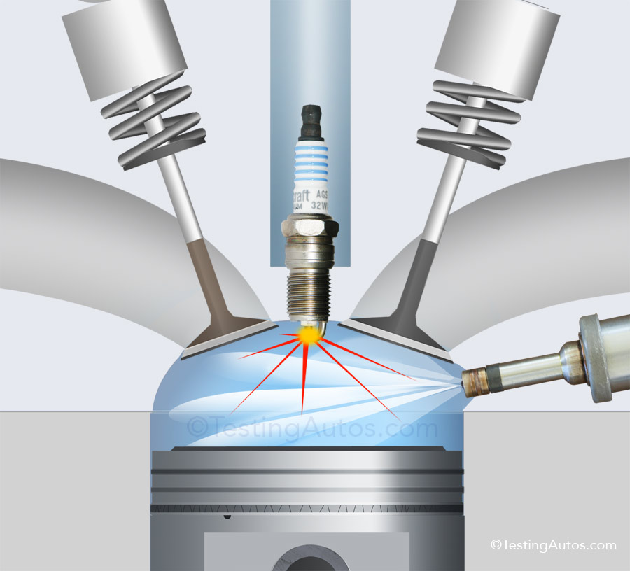

Figure 7: Operation of spark plug